***Project Phase IV Report***

***On­­­***

**E -Commerce using PHP**

**Submitted for the requirement of**

**Project course**

BACHELOR OF ENGINEERING

**COMPUTER SCIENCE & ENGINEERING**



**Submitted to: Submitted By:**

|  |  |
| --- | --- |
| **NAME** | **UID** |
| **Sujata Singh** | **20BCS7295** |
| **Pushpinder Singh** | **20BCS7300** |
| **Shubham Sharma** | **20BCS7327** |

**Er. Nisha Rani**

**(E12351)**

**Co Supervisor Signature**

**Er. Triveni Lal Pal**

**(E12336)**

**DEPARTMENT OF COMPUTER SCIENCE & ENGINEERING**

**CHANDIGARH UNIVERSITY, GHARUAN**

**June 2022**

### ABSTRACT

This project titled “E-commerce ” website using PHP. The aim to build a responsive website which involves buying and selling of goods and services. Now, user can browse online shops, compare prices and order merchandise sitting at home on their PC. Much like a traditional physical retail store, e-commerce websites allow consumers to buy and sell to one another on a designated platform.

Searching for an item, seeing the description, adding to cart – all steps

happen in no time at all. In the end, the buyer is happy because he has the item and didn’t have to travel far. Here the seller has full control over customization , he can mention offers available, discounts etc. It provide flexibility to customers , the product and services are ready 24x7.

### Table of Content

|  |  |  |
| --- | --- | --- |
| Sr no. | Topic | Page No. |
| 1 | Use of Modern tools in design and analysis | 4-6 |
| 2 | Discussion and report/results analysis | 7 |
| 3 | Project management and Professional communication (Presentation) | 8-12 |
| 4 | Attainment of stated outcomes | 14-15 |

**Use of Modern tools in design and analysis**:

* Windows 10 operating system has been used for stable and supportive features.
* A system with minimum 2 GB RAM required.
* VS code-
* Visual studio code is a source code editor made by Microsoft for windows , linux and macros. Features include support for debugging, syntax highlighting, intelligent code completion, snippets, code refactoring, and embedded Git. It is the most widely used code editor by the developers .

* Chrome browser
* Google Chrome is a cross-platform web browser developed by Google. It was first released in 2008 for Microsoft Windows built with free software components from Apple WebKit and Mozilla Firefox. It was later ported to Linux, macOS, iOS, and Android where it is the default browser built into the OS.

Further this project has been divided into two sub-divisions :

* Front -End- It specifies the appearance of website .
* Back-End- It includes the management of data at the back-end of website.
* For Front End designing we have used HTML , CSS & JAVASCRIPT.
* For Back End maintenance PHP & MySql has been used.
* **HTML**

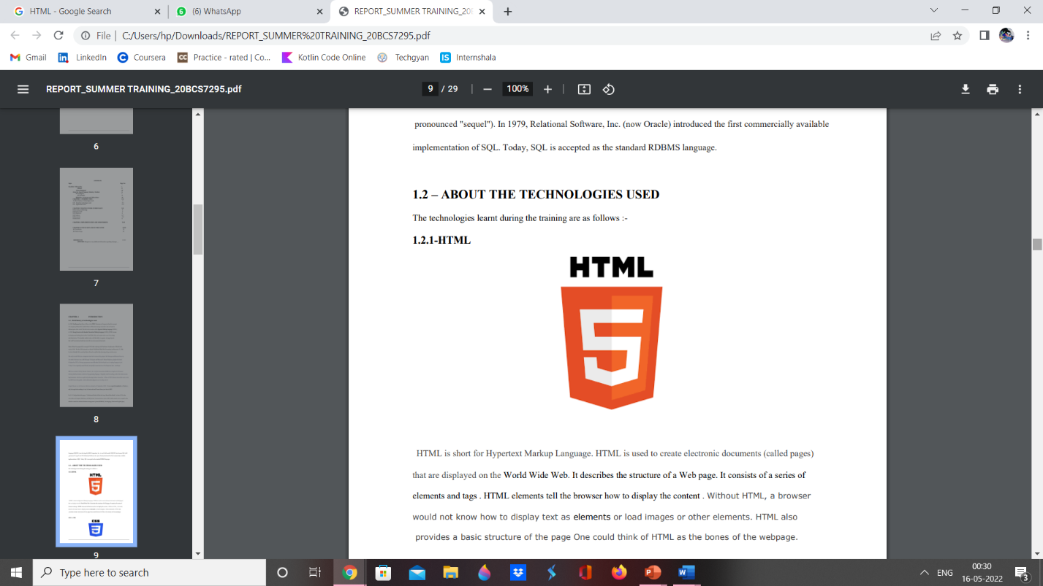

HTML is short for Hypertext Markup Language. HTML is used to create electronic documents (called pages) that are displayed on the World Wide Web. It describes the structure of a Web page. It consists of a series of elements and tags . HTML elements tell the browser how to display the content . Without HTML, a browser would not know how to display text as elements or load images or other elements. HTML also provides a basic structure of the page One could think of HTML as the bones of the webpage.

* **CSS**

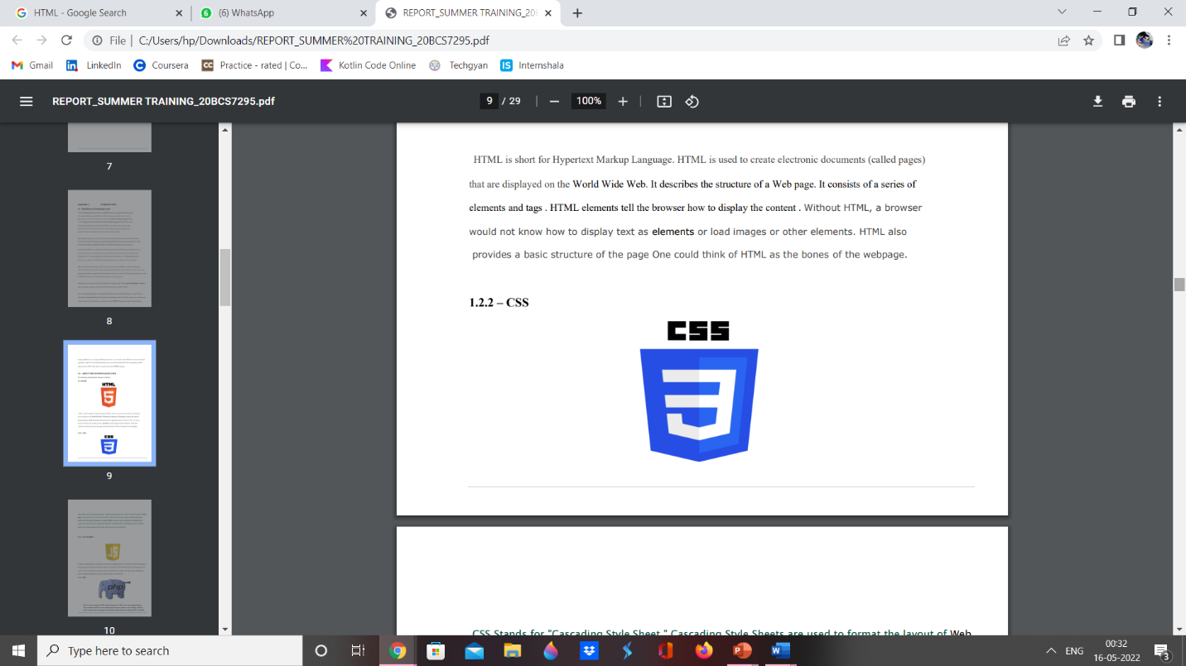

CSS Stands for "Cascading Style Sheet." Cascading Style Sheets are used to format the layout of Web pages. They can be used to define text styles, table sizes, and other aspects of Web pages that previously could only be defined in a page's HTML. Once the style is defined in cascading style sheet, it can be used by any page that references the CSS file. Plus, CSS makes it easy to change styles across several pages at once.CSS is like the skin to the websites.

* **JAVASCRIPT**

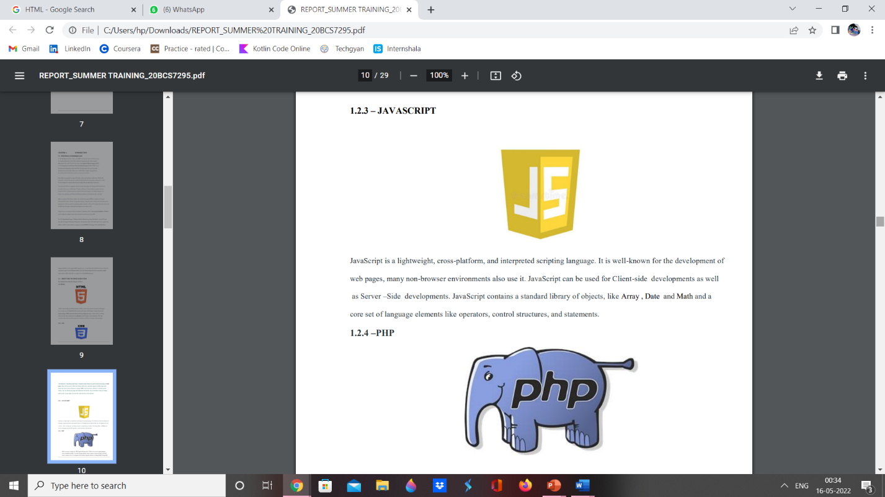

JavaScript is a lightweight, cross-platform, and interpreted scripting language. It is well-known for the development of web pages, many non-browser environments also use it. JavaScript can be used for Client-side developments as well as Server –Side developments. JavaScript contains a standard library of objects, like Array , Date and Math and a core set of language elements like operators, control structures, and statements.

* **PHP**

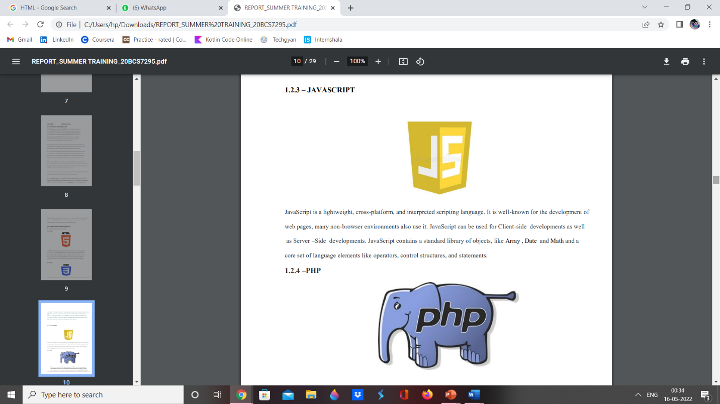

PHP is a recursive acronym for "PHP: Hypertext Preprocessor". PHP is a server side scripting language that is embedded in HTML. It is used to manage dynamic content, databases, session tracking, even build entire e-commerce sites. It is integrated with a number of popular databases, including MySQL, PostgreSQL, Oracle, Sybase, Informix, and Microsoft SQL Server. PHP performs system functions, i.e. from files on a system it can create, open, read, write, and close them. PHP can handle forms, i.e. gather data from files, save data to a file, through email you can send data, return data to the user.

* **MYSQL**

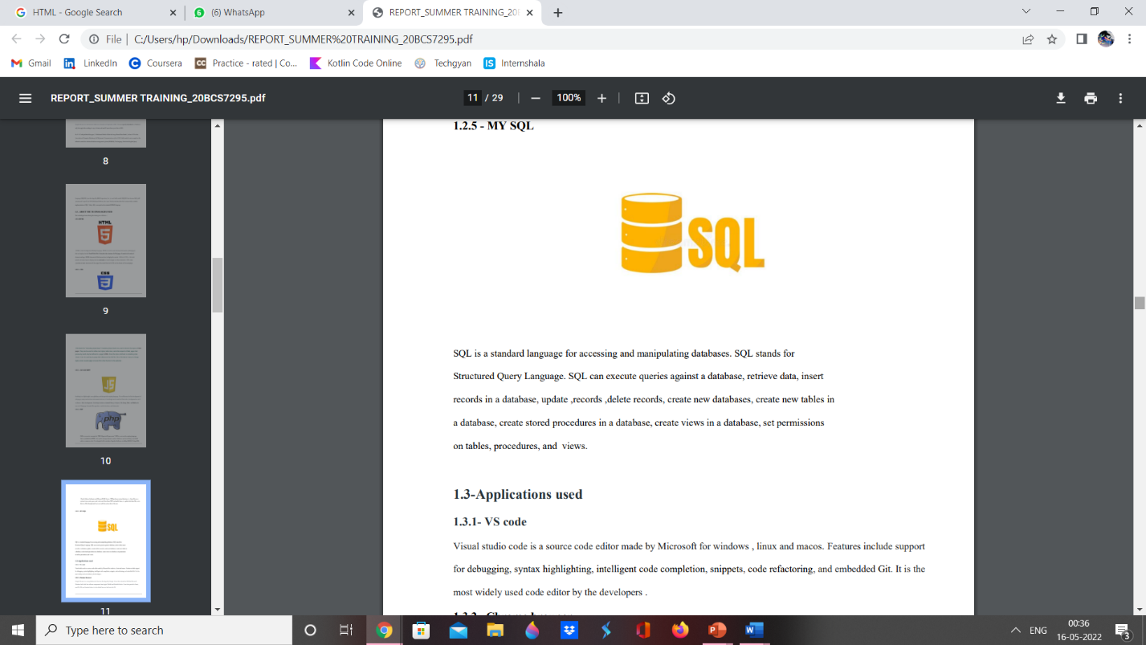

SQL is a standard language for accessing and manipulating databases. SQL stands for Structured Query Language. SQL can execute queries against a database, retrieve data, insert records in a database, update ,records ,delete records, create new databases, create new tables in a database, create stored procedures in a database, create views in a database, set permissions on tables, procedures, and views.

**Discussion and report/results analysis**

This project aims to develop an user friendly online shopping e commerce website for customers with the goal so that it is very easy to shop your loved things from a extensive number of online shopping sites available on the web. With the help of this you can carry out an online shopping from your home. Here is no compelling reason to go to the crowed stores or shopping centers during festival seasons. You simply require a PC or a laptop and one important payment sending option to shop online.

* Existing system

The existing system is of going to store and buy the products you want to. Basically it needs you to visit the particular shopping stores or mall. It requires lots of manual work. Suppose you need to buy any clothes, the visiting customers must have tried the product even if he/she didn’t purchased it, now you will get the product which has come to contact of any other person. Other disadvantages are: Not all stores and businesses have the exact item for the customers. Since you want to see something and visit every store, you are under pressure. There is some limited time of when the store us open and shut.

* Designed system

The proposed system helps in building a website to buy, sell products or goods online using

internet connection. Unlike traditional commerce that is carried out physically with effort of

a person to go and get products, eCommerce has made it easier for human to reduce physical

work and to save time. The basic concept of the application is to allow the customer to shop

virtually using the Internet and allow customers to buy the items and articles of their desire

from the store. E-commerce is fast gaining ground as an accepted and used business

paradigm.

**Project management and Professional communication**

**(Presentation)**

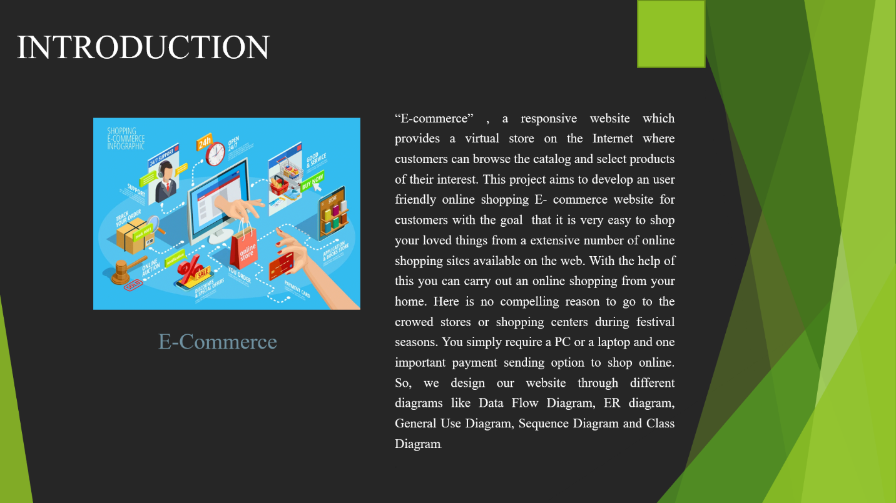

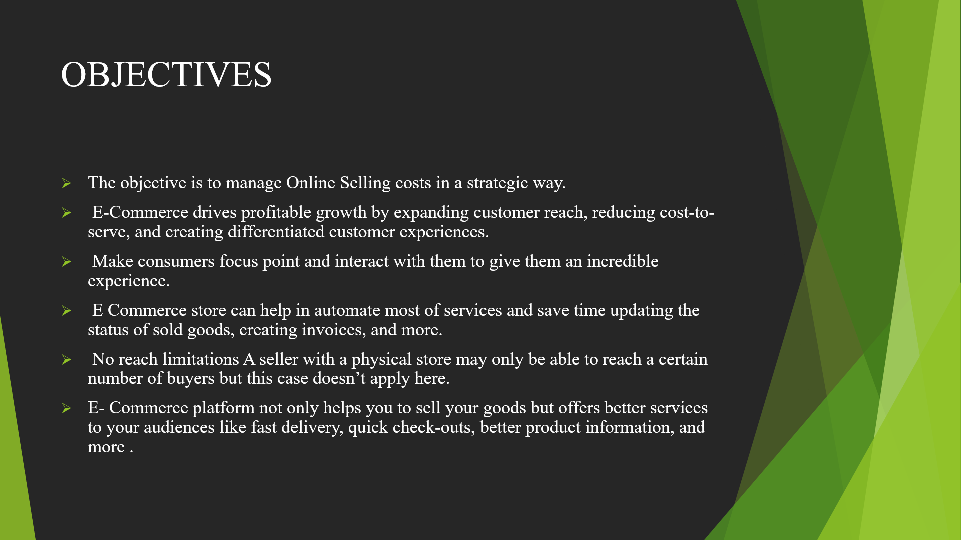



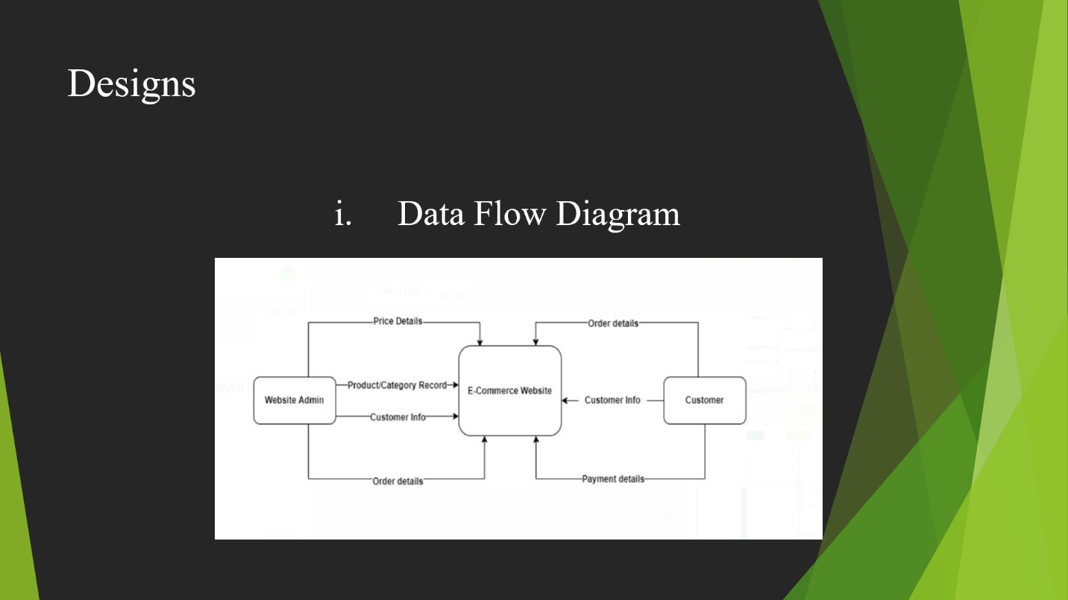

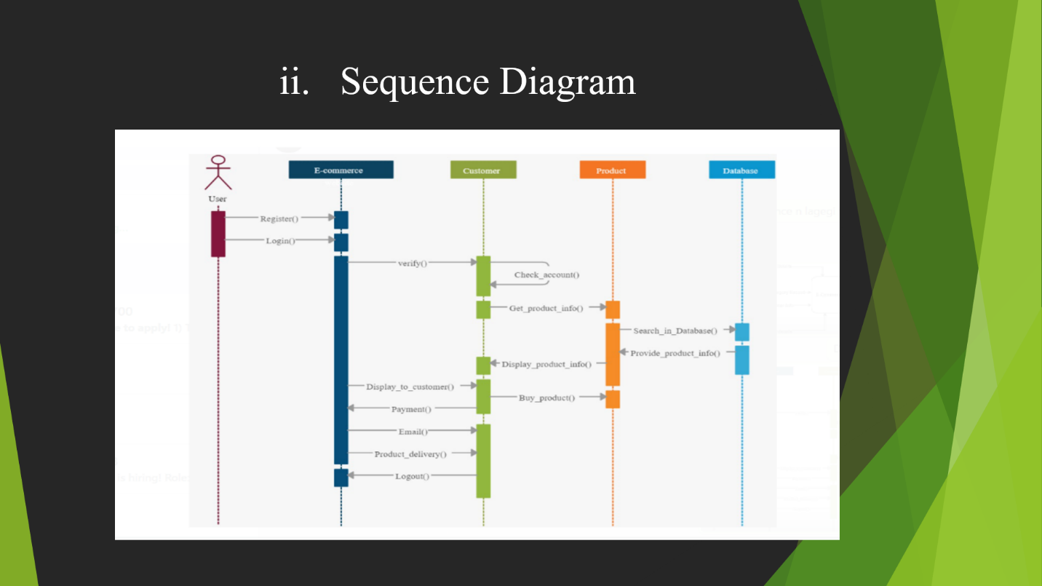

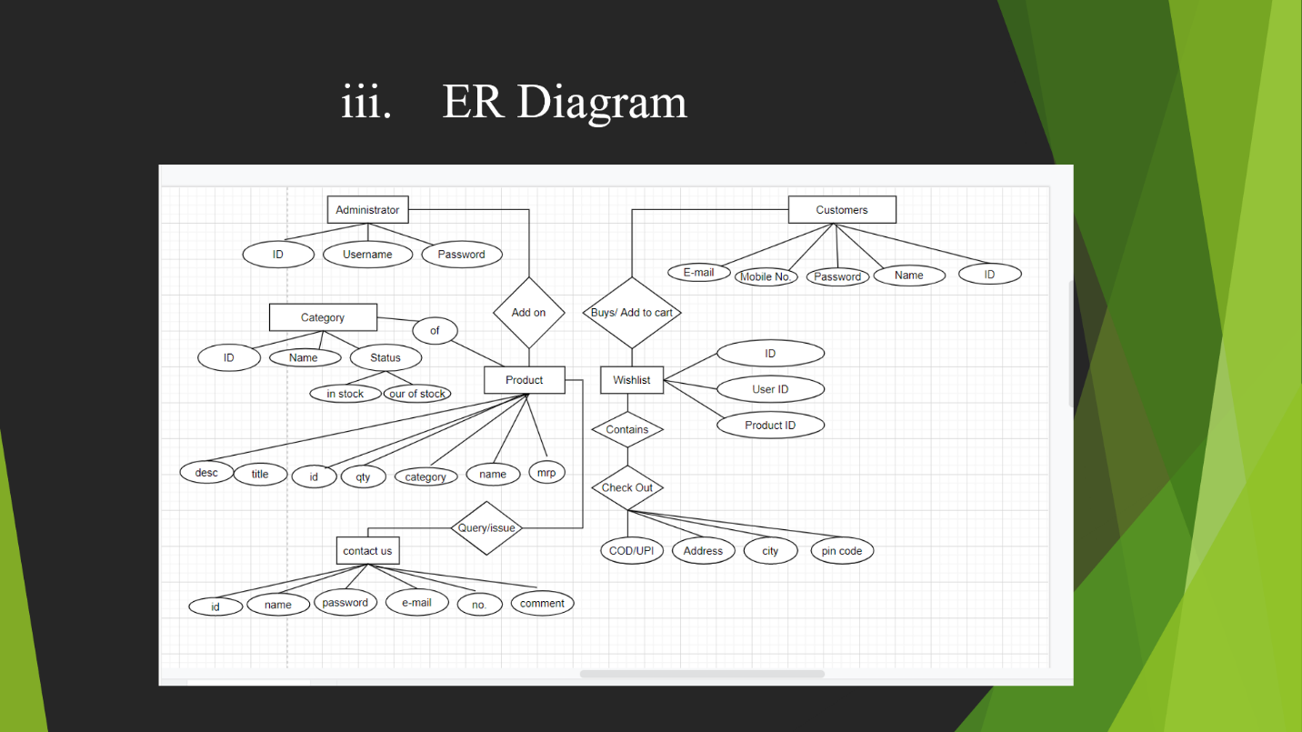

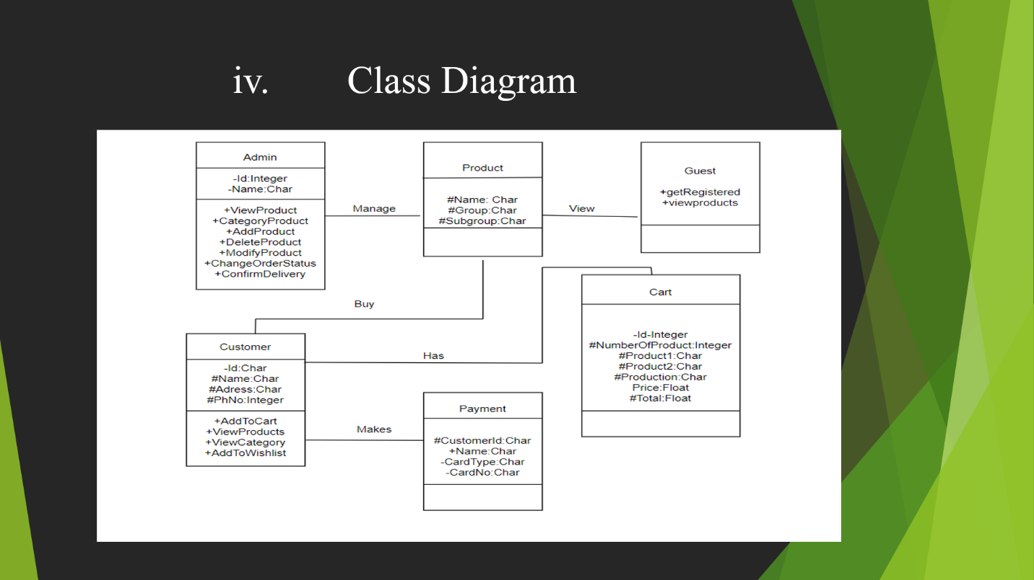

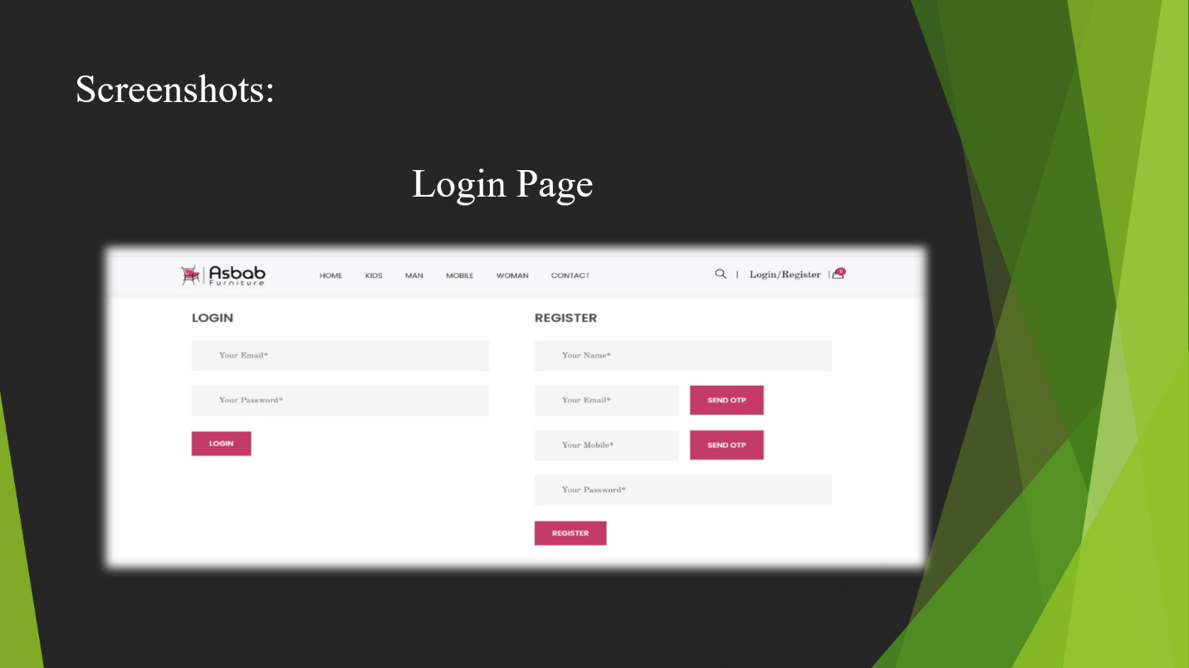

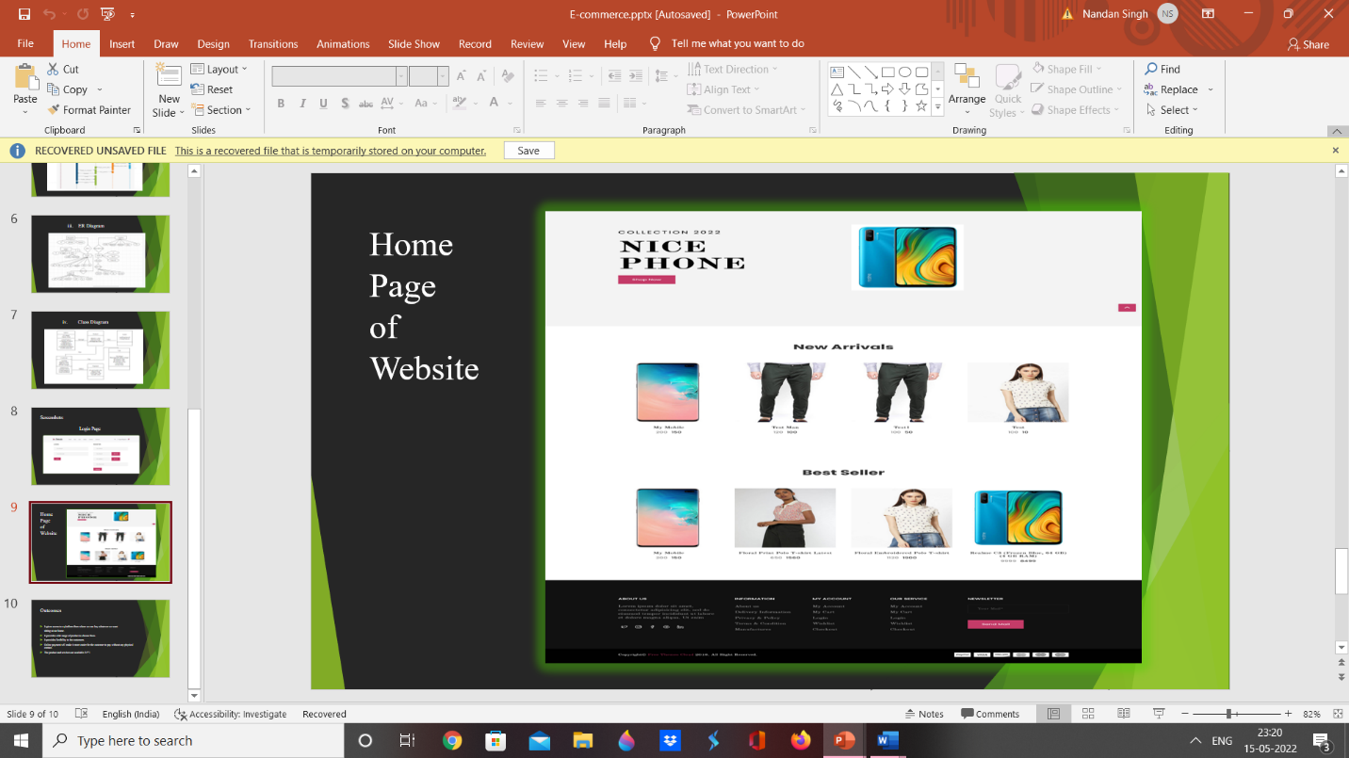

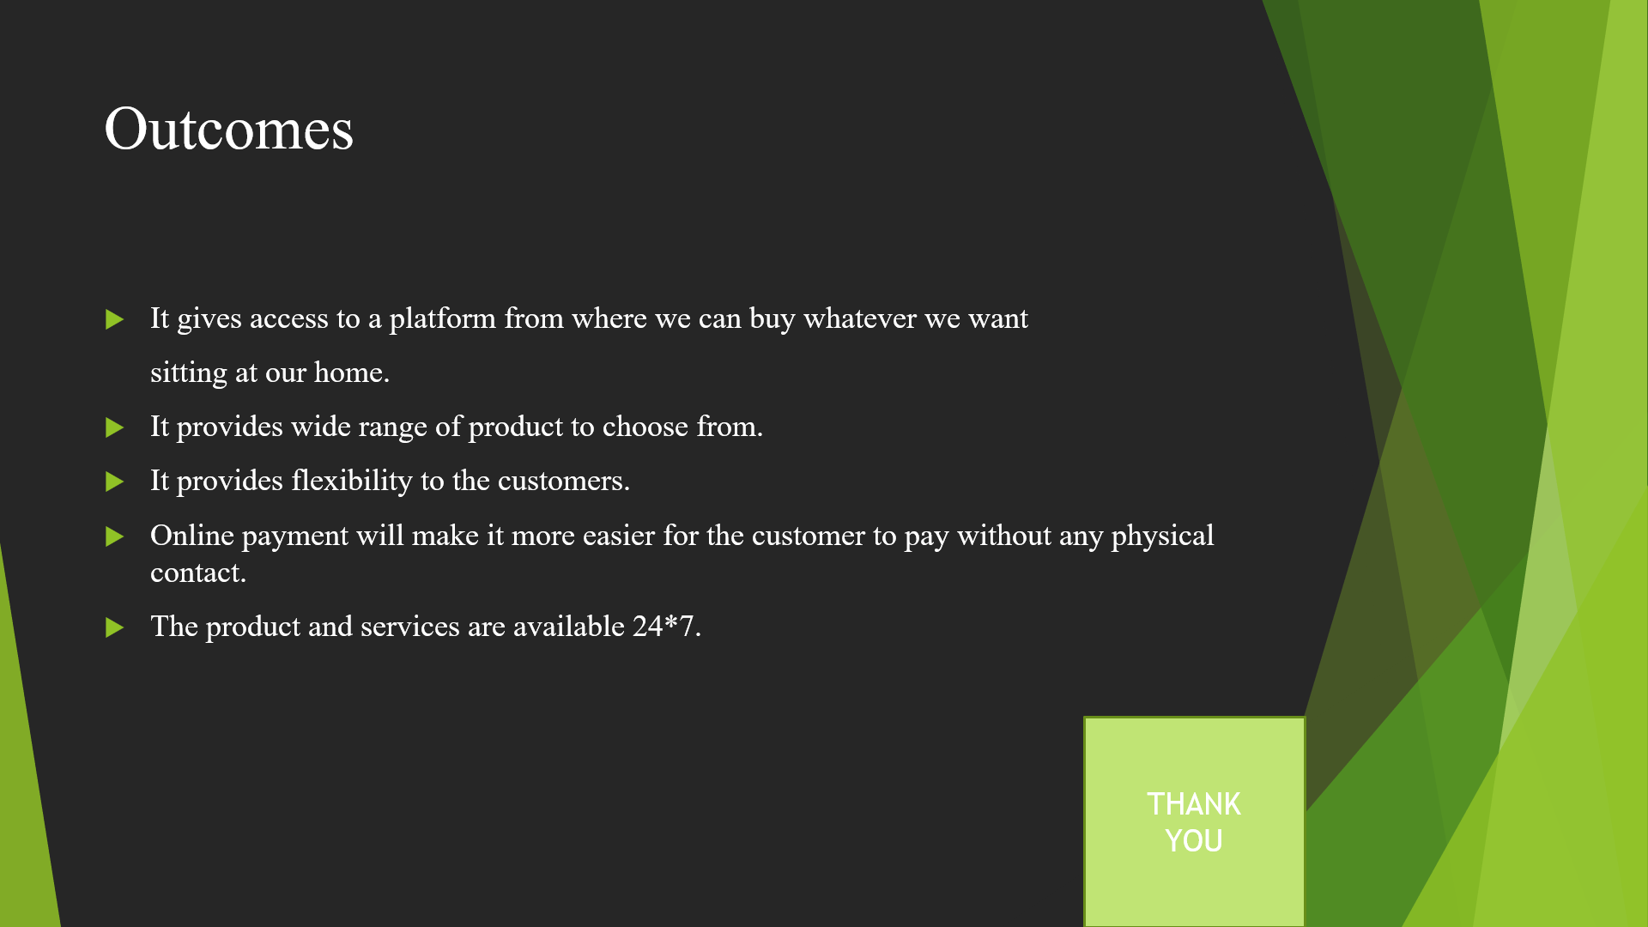

**Attainment of stated outcomes**

Traditional shopping has been replaced to a large extent because of online shopping i.e E-Commerce . With the advancement of technology as everything is going towards being digital ,then why not shopping. Now, Customers can spend less time shopping for what they want. They can easily browse through many items at a time and buy what they like. When online, customers can find items that are available in physical stores far away from them or not found in their locality. A product listing is what the customer sees when they search for an item. This is one advantage in ecommerce meant for the seller. Sellers can add many images, a description, product category, price, shipping fee and delivery date. So, in just one step you can tell the customer many things about the item. Creating your listing shows the buyers what you have.

Demand of online purchasing is rapidly increasing. Form business point of view E-commerce

had created a lot of opportunity to fresh starter as they can startup business with low cost no

need of physical store they just need to have one online website where they showcase their

products and services.

The main purpose of the project was learning how to implement the knowledge you have to a responsive website. Planning for making website includes where we need to present the specific content, how to give a proper structure to the website. Development of E-commerce

website is often hard if one does not have proper knowledge where to start. Thus, planning of the project becomes the most important part of the project. Now, it became very easy for the

customers to create an account, choose from a variety of products. Users can add

item to the cart, can remove item from the cart and can buy those items with a single click, which

will help to save time and effort of customers. It provides 24 *7 services.

**SDG Goals Attained**

Goal 1: Good health and well-being

We were able to achieve this goal since our site focuses on purchasing and the website

interactions help the user to get to the item easily.

Goal 2: Gender Equality

Our website is made for selling and purchasing of products irrespective or gender or caste

discrimination.

Goal 3: Climate Action

We made the website which doesn’t require any resources which could harm the

environment and effect the climate.

Goal 4: Life on Land

Our model doesn’t affect any environmental factors and its helping people in finding

products online at a cheaper rate with home delivery option.

**References**

1) https://blog.cylindo.com/augmented-reality-furniture-ecommerce

2) https://www.pepperfry.com/

3) https://www.ikea.com/in/en/

4) https://www.w3schools.com/php/

5) https://serverguy.com/ecommerce/php-open-source-ecommerce-platforms/